Assignment:1

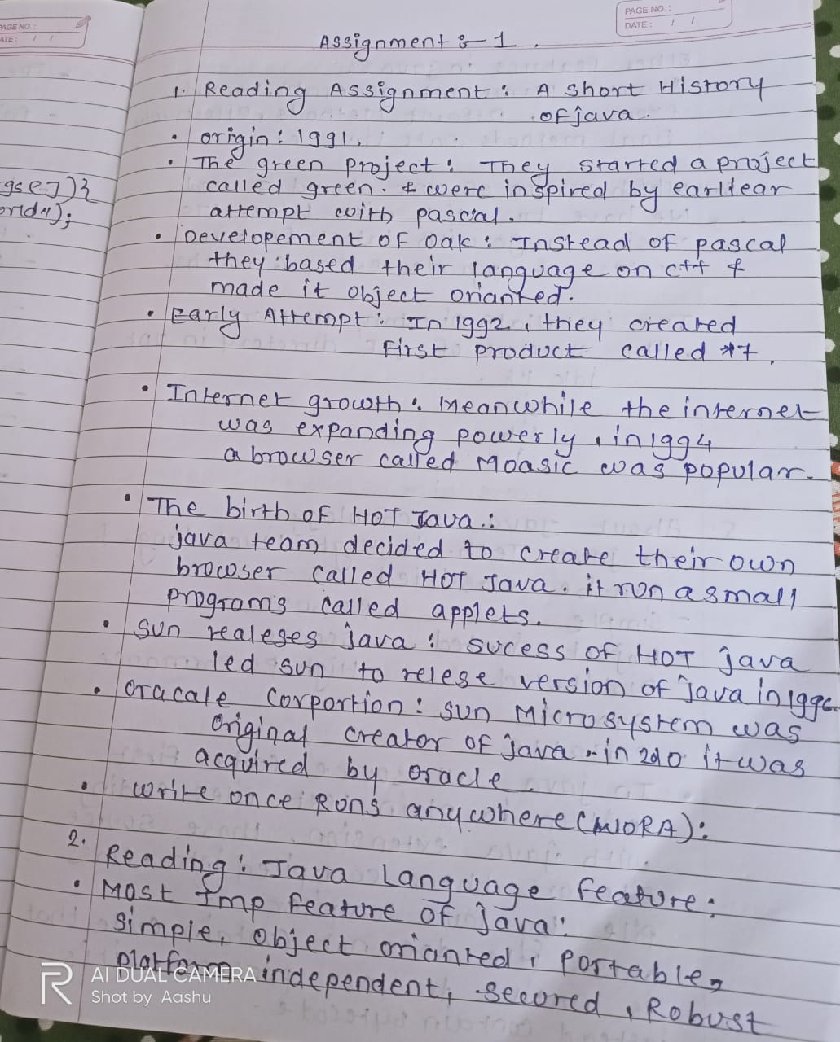

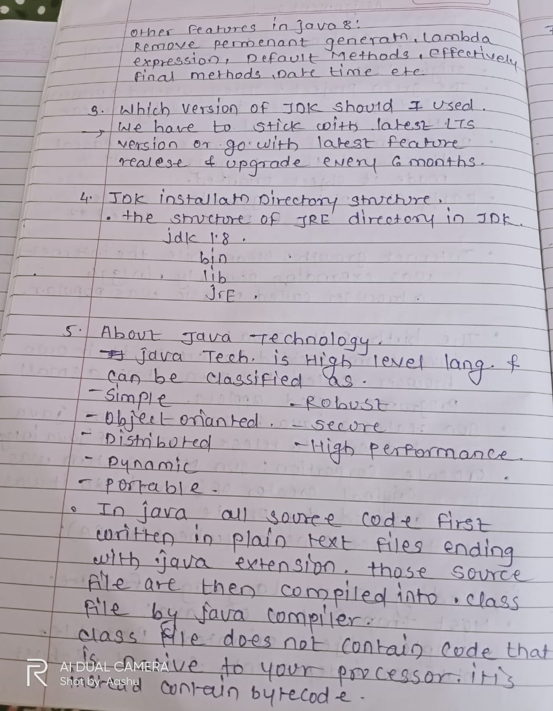

6. Coding Assignments

1. Hello World Program: Write a Java program that prints "Hello World!!" to the console.
2. Compile with Verbose Option: Compile your Java file using the -verbose option with javac. Check the output.
3. Inspect Bytecode: Use the javap tool to examine the bytecode of the compiled .class file. Observe the output.
4. class first{

    public static void main(String args[]){

        System.out.println("Hello world!!");

    }

}

Output:

PS C:\Users\ashwi\Desktop\java> javac first.java

PS C:\Users\ashwi\Desktop\java> java first

Hello world!!

PS C:\Users\ashwi\Desktop\java> javap -c first.java

Error: class not found: first.java

PS C:\Users\ashwi\Desktop\java> javap -c first

Compiled from "first.java"

class first {

first();

Code:

0: aload_0

1: invokespecial #1 // Method java/lang/Object."<init>":()V

4: return

public static void main(java.lang.String[]);

Code:

0: getstatic #7 // Field java/lang/System.out:Ljava/io/PrintStream;

3: ldc #13 // String Hello world!!

5: invokevirtual #15 // Method java/io/PrintStream.println:(Ljava/lang/String;)V

8: return

}

